Software Requirements Specifications
(Updated)

Group AIJNW
Abdulrahman Alandijani
Brian Little
Ibrahim Alsamayen
James Peters
Nikki Meyer
Kitchen Komplete
Software Engineering, CSCE 3444, Summer 2020

Table of Contents
1. Introduction 2
1.1. Purpose 2
1.2. Scope 2
1.3. Definitions, acronyms, and abbreviations 2
1.4. Overview 2
1.5. References 2
2. Overall Description 3
2.1. Product perspective 3
2.2. Product functions 3
2.3. User classes and characteristics 4
2.4. Constraints 5
2.5. Assumptions and dependencies 5
3. Specific Requirements 6
3.1. External interface 6
3.1.1. User interface 6
3.1.2. Hardware interface 7
3.1.3. Software interface 7
3.1.4. Communication interface 7
3.2. Functional requirements 7
3.3. Non-Functional requirements 9
3.3.1. Usability 9
3.3.2. Reliability 9
3.3.3. Performance requirements 9
3.3.4. Safety requirements 9
3.3.5. Security requirements 10
3.3.6. Legal 10
3.4. Design constraints 10
4. Appendices 11

Introduction

Purpose
This document describes the system requirements and specifications of the website application, “Kitchen Komplete.” The document relates in detail what “Kitchen Komplete” is meant to do, how it is meant to be used by its users, and various use cases that it is meant to handle. It will also detail how the application will accomplish these goals, including the technology used and programming languages/libraries utilized. It will also include a design overview of the user interface/user experience for the application.

Scope
“Kitchen Komplete” is a website application that allows a user to search for recipes using the ingredients in the recipe. The user will input a list of the ingredients they have, or will draw from the list they have saved with the site, and will receive a list of recipes that use those ingredients, sorted based on relevance and accuracy. This allows users to easily find recipes they can make with just what they have in their home. A further goal is to allow users to submit their own recipes to the database, allowing sharing between users. The goal is to provide an easy-to-use, helpful tool for home chefs.

Definitions, acronyms, and abbreviations
KK - “Kitchen Komplete”
HTTP - Hypertext Transfer Protocol
OCR - Optical Character Recognition
HTML - Hypertext Markup Language
Go - The Go Programming Language
CSS - Cascading Style Sheets

Overview
This document begins with this brief introduction. The introduction provides a summary of the document’s purpose, an explanation of “Kitchen Komplete” and its intended use, and then an overview of the rest of the document’s contents.
Next, the document provides an overall description of “Kitchen Komplete.” This includes an explanation of why it was made, a summary of its primary functions (including appropriate diagrams for use cases), a description of the various user classes and what defines them, the constraints upon the application, and factors that directly influence the application’s requirements.
Finally, the document covers the specific requirements of the application. This includes an overview of the external interface, such as the user interface and hardware interface. Then, it provides an explanation of the functional and non-functional requirements. Lastly, it relates constraints on the application’s design.

References
CSS: https://www.w3.org/Style/CSS/Overview.en.html
Go: https://golang.org/

Overall Description

Product perspective
Our product is a new and original idea! James came up with the idea because he felt that the meal tracking app that he uses did not go far enough!! Kitchen Komplete aims to solve the problem of grocery shopping without having to take a manual inventory of what's in your cabinet or fridge! Surely you’ve gone on a shopping trip, walked down the ketchup aisle and thought to yourself, “Do I have ketchup at home?” Ponder no more. Kitchen Komplete is here to save the day!

Also you can save your favorite recipes. This webapp is perfect for the meticulous and detail oriented home cook!

Product functions
Confirmed Features (Basic Functionality)
- Find Recipe
- Enter Recipe
- Log In
- Register Account
Stretch Features
- Pantry Function
- Update pantry based on recipes cooked
- Using OCR to scan receipts and add kitchen items to your inventory automagically!
- Quickly share recipes with friends!
- Subscribe to your favorite professional chefs to see what they suggest you cook!
- Rating system for verified users
- Select a week's worth of recipes and calculate what ingredients you need to pick up from the store!!
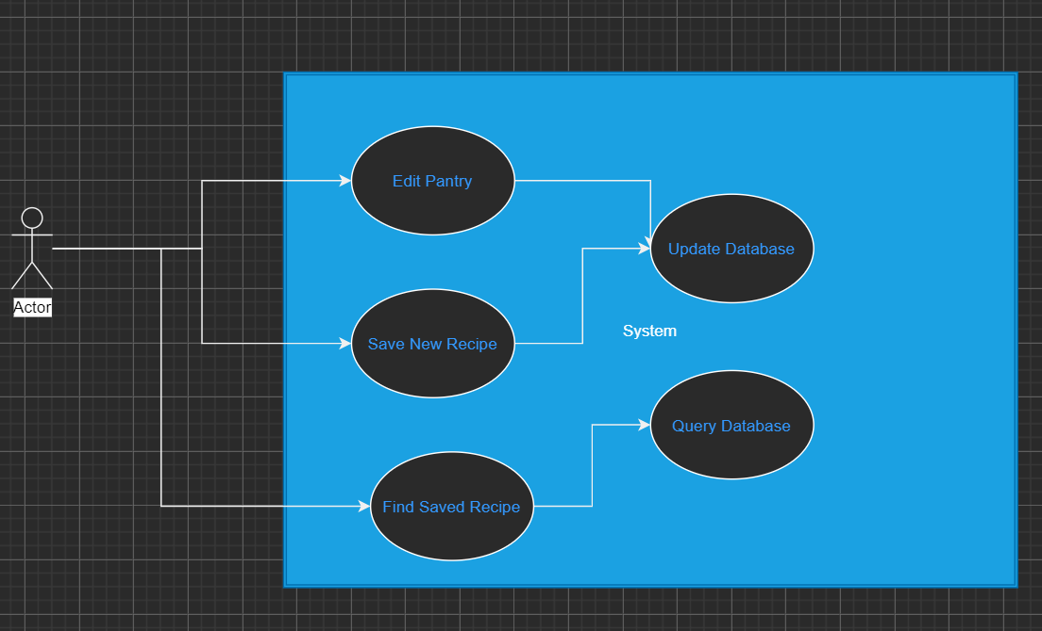
Figure 1

User classes and characteristics
The intended users of the system are us, the moderators, and the average home cook. Home cooks are expected to be busy and want a quick, easy-to-use system that does not require a lot of know-how or prior knowledge.
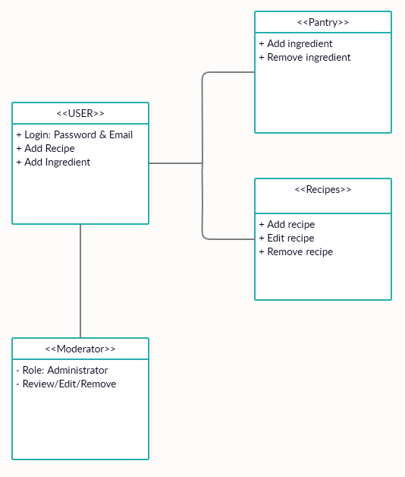Figure 2

Constraints
Currently we are constrained by the limited number of recipes in our database! Users are able to add their own custom recipes and save them for later use, but we would like to suggest recipes as well. We are looking for an api or to develop a web scraping application to help add recipes to our database.
We would like to add text notifications but that would cost money.

Assumptions and dependencies
The primary factors influencing the development of our application include:
- Ease of use: The application is intended to be intuitive to users, and it will need to be tested to that end. As a focus of the system, our requirements are centered around this.
- Ease of development: This application is the first for most of the team. It is a learning experience, and that will affect many of the requirements. Typically, decisions will prefer what would be simpler and more efficient to develop.
- Cost to develop and deploy: We do not intend to make use of any drastically expensive resources. The cost of developing this application is minimal.

Specific Requirements
Explanation of the software’s various requirements.

External interface

User interface
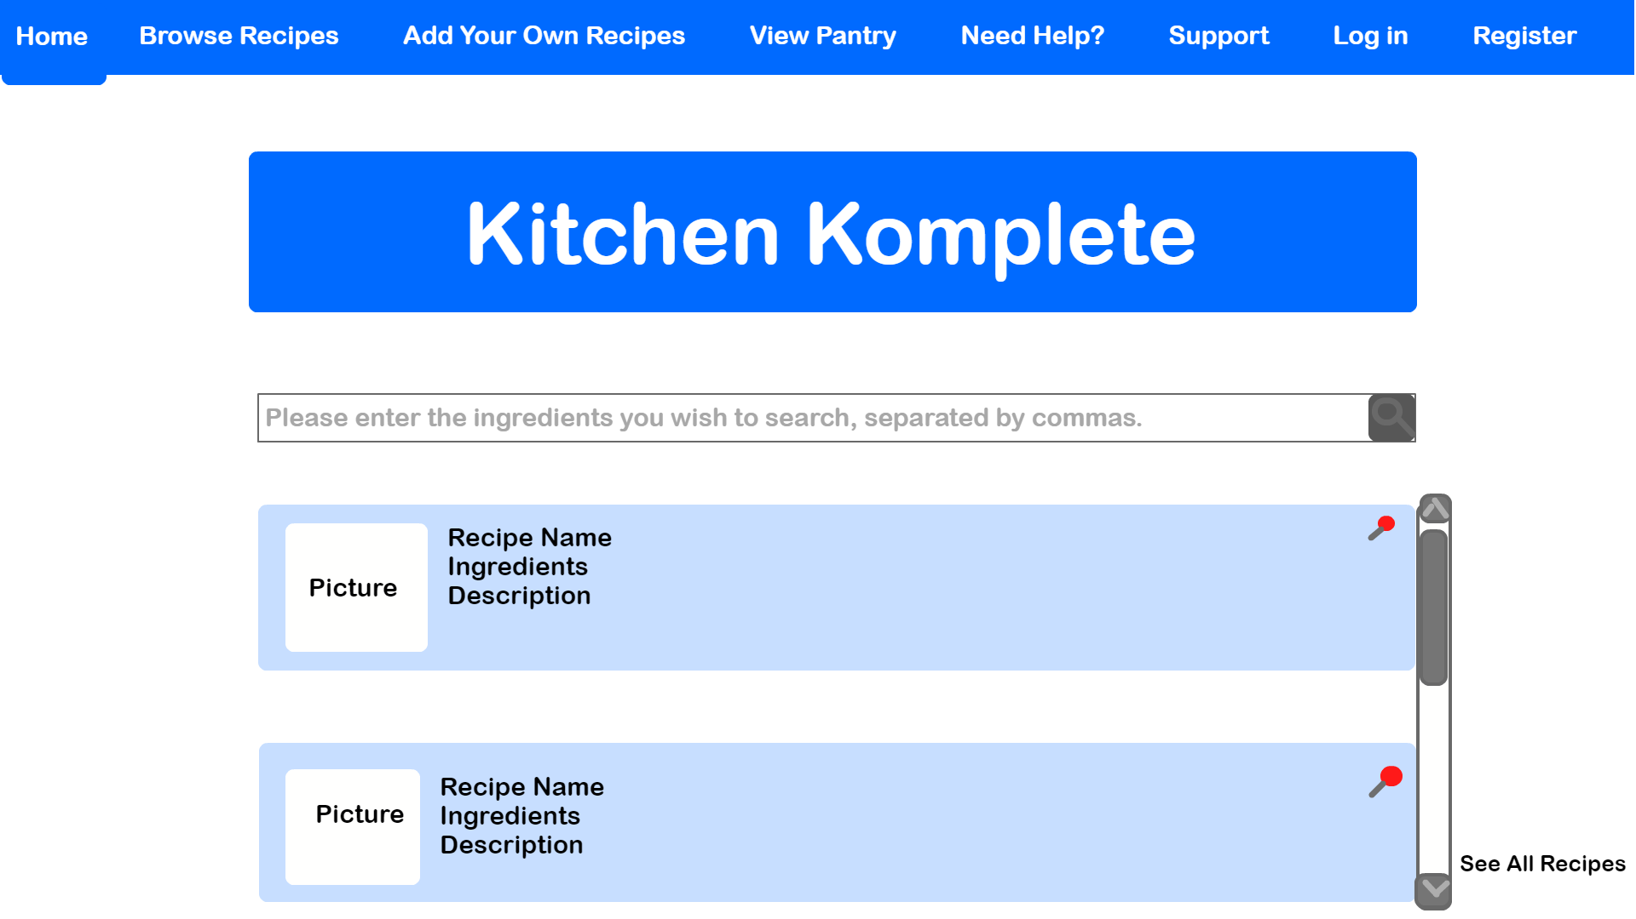Figure 3
The webpage will place the users immediately into the homepage with a toolbar, as shown in Figure 3. The user will have several options at the toolbar that bring them to separate pages, including
- return to home page
- browse full list of all recipes on site
- visit their profile, where they can contribute their own recipes
- log in
- register
In addition, the center of the screen will have a search bar that the user can enter a comma-delimited list of ingredients into in order to search for recipes. This search bar is the primary function of the site and the center of the User Interface, and when used will bring up a scrollable list of results sorted by relevance. The user will also be able to save their pantry in a profile that lists their ingredients, which they can alter and make edits to as they see fit, allowing them to create an easy grocery list for the recipes they wish to create. This profile will also store their “pinned” recipes, which they can view later.

Hardware interface
Since it is built as a web application, the software should function on desktop, tablet, and mobile. This means the functionality will work with mouse/keyboard and touch screen. The application’s data and processing will be hosted on Heroku’s services for hosting websites. A Raspberry Pi was also considered, but it was decided that it would be less reliable.

Software interface
We intend to utilize a simple tagging system to allow the application to search through the database of recipes. Every recipe can be tagged with the ingredients it uses, and instead of scouring recipes our application will be able to simply look for those tags and return relevant entries. We can find “proximity” to a user’s query by prioritizing recipes that have more tags matching the user’s query while having fewer tags that do not. For example, a recipe matching three of a user’s queried ingredients while only having two ingredients that do not match will be returned at a higher priority than one that only matches two ingredients or one that has four ingredients that do not match.
To accomplish these goals, the web application is utilizing the HTML template library for Go for the back-end. This includes database functionality and searching. Meanwhile, the front-end will be handled by using CSS with HTML. This will cover the UI of the application and handle user input.

Communication interface
“Kitchen Komplete” does not directly rely on any sort of external communications, such as e-mail. It is not planned that it will have any functions to notify or email users about updates or information, wanting to remain lightweight and unintrusive. As a website, the application requires a web browser to access. It will be utilizing Hypertext Transfer Protocol to process data, as typical for websites. As with all HTTP processes, it will use port 80.

Functional requirements
Confirmed Features (Basic Functionality):

- Find Recipe
When looking for recipes, suggestions based on the current ingredients registered in the user’s profile would pop to the user's view when looking for recipes. However, for an old fashioned search, the search engine is implemented with a tagging system that would allow users to search by certain ingredients or certain chefs.
- Enter Recipe
Users are allowed to add recipes to the public database as well as to the private section of the database. When choosing a public option the recipe would be viewable as well as shareable by all other users; however, when the user chooses private then only he can view and share the recipe.
- Log In
When attempting to login, the user is required to enter their username and password only. Also, the user could save their username for a quicker login in the future.
- Register Account
When attempting to create a new account, the user is required to enter a username, password, and an email only for account details.. In the future, if the user wanted to get more advanced in the app, they could verify their account to become a chef.

Stretch Features:
- Pantry Function
The user would be able to access and view all ingredients in their pantry. The pantry is stored in the database and kept as an element for each individual user’s profile, which they can log into. This allows them to access their pantry from any computer, so they can see what ingredients they might need while out of their home. There might also be an option to provide a notification when an ingredient is almost out.
- Update pantry based on recipes cooked
When a new recipe is marked done by the user, the program will automatically update the user’s pantry database. ingredients that are about to run out, would be added to the grocery list to notify the user on the grocery shopping day.
- Using OCR to scan receipts and add kitchen items to your inventory automagically!
The user could easily scan ingredients or products purchased from the supermarket to quickly add them to the pantry database.
- Quickly share recipes with friends!
The users could easily generate a sharable link to any public recipe; however, for private recipes, only the owner of the recipe is allowed to generate a sharable link.
- Subscribe to your favorite professional chefs to see what they suggest you cook!
The users are capable of subscribing to their choice of chef; in order to receive notifications via email when the chef has uploaded a new recipe, or to quickly access their favorite chef’s profile.
- Rating system for verified users
To allow fairness in the system a user verified rating system will be implemented to prevent fake rating, allow users to add comments, allow users to give their opinion, or to appreciate the chef’s piece-of-art.
- Select a week's worth of recipes and calculate what ingredients you need to pick up from the store
The user could add recipes to a list called dishes of the week. This list is kind of a quick reference to access later within the week as suggestions from a previous lookup . The user could either pick from his favorite chef’s recipes, a random chef’s recipe, or a generated list of recipes based on ingredients in the user's pantry. When those recipes are added to the list, “Kitchen Komplete” will calculate the missing ingredients for all the recipes in that list, and it will add the missing ingredients to the grocery list to notify the user on the grocery shopping day.

Non-Functional requirements
    - Usability
The system will ideally be easy to use. The goal is to have a system that simply requires a comma-delimited list of ingredients from the user. Potential issues could be found in the user misspelling ingredient names or forgetting to include commas, or in ingredients having multiple names.
    - Reliability
The web application is designed to have a low chance to fail catastrophically. The likeliest failure point will be a search not returning results due to an issue with search queries or stored information. The application does not deal directly with valuable and sensitive information to avoid any potential risk.
Due to utilizing the Heroku web hosting services, the reliability for “Kitchen Komplete” should fit their promised reliability for the service. That means that the availability of the service should exceed 99.9% of the time and data should only be deleted when specifically requested. In addition, MongoDB is a stable database platform that should be reliable.

Performance requirements
The application is relatively lightweight. It will simply need to perform a search through a list of recipes to match the search query. It will then return a handful of relevant recipes. Altogether, this should not be demanding either on the database or on the user requesting information. Even with a large volume of users, Heroku’s web hosting should be able to easily handle the peak traffic.

Safety requirements
The web application is designed to be low risk. The data it handles is not sensitive or valuable, so in the event of an issue there is little risk or danger. To aid in this, Heroku’s web hosting provides measures to protect stored data. The largest potential risk would be losing the entire database, and to combat this a backup of the database can be made and stored once a month.

Security requirements
Go is a naturally secure language. In addition, MongoDB provides security for the stored database that will aid immensely in protecting user data. This will protect the back-end information and the data the web application handles. The front-end will be light on security, as it seems unnecessary. However, Heroku’s web hosting provides some of its own built-in security, which should cover the website’s needs.

Legal
The application uses very little information and thus has few legal ramifications. Users that submit recipes to the site should be made aware that they do so with the understanding that the recipe is not the intellectual property of another and is being submitted for free use by all of the site’s users.

Design constraints
The system will have a front-end and a back-end that will interact to process data and user input and provide the appropriate response. The front-end will utilize the HTML scripting language, as well as CSS. The front-end will provide the user interface, handle user response, and take care of most of the aspects of the website and its front-facing elements. Meanwhile, the back-end will use the Go programming language and its HTML template libraries. It will handle the database, information storage, information processing, and the returning of necessary data the front-end requires.
As a website, the application is expected to run properly on any operating system. It would rely on the web browser to handle operating system-level details. Therefore, any web browser that correctly handles HTML for websites should be suitable for the system. Even though no issues are expected, testing will be conducted on multiple operating systems and web browsers to ensure the system has full functionality on all of them.
Similarly, the system should be optimized to run on any level of machine. It is a lightweight website utilizing simple programming libraries. The application should not be taxing on the user’s computer. If the computer can run a web browser, it should have no issues using the website’s full functionality. To be certain about this, testing will be conducted on multiple computers to ensure the website application runs properly.
The back-end segment of the system needs a certain amount of memory to store its database of recipes, which will be hosted by MongoDB. In addition, it will have a database of users and their information that need to be stored. While the number of recipes and users may grow large over its lifetime, each entry is expected to be relatively small. The largest potential increase in data size would come from associating images with recipes. Otherwise, it would be a matter of storing plain text strings and numbers. While this is not expected to be a large amount of data, Heroku’s web hosting service should be able to handle the full size of the database.

Appendices
CSS is a style sheet language that can work with HTML to allow a developer to more easily build and design pages. The developer can create more intuitive pages that are nicer-looking and easier to use.
Go has access to HTML template libraries that make working with HTML modules and pages much easier. It allows a developer to glue the front-end and back-end together more easily.
Heroku will be the web hosting solution used for this application. It was selected for its built-in security, load-balancing, network reliability, and ease of use. In addition, it is free.

